Module 1 - R Practice AssignmentReport: Regression Diagnostics with R

Ayush Anand

**Northeastern University: College of Professional Studies**

**ALY 6015: Intermediate Analytics  
 Professor – Valeriy Shevchenko**

**7th November 2024**

# Table of Contents:

* About the Dataset
* Data Exploration and Handling Missing Values
* Data Cleaning
* oxplot of Sale price
* Data Visualization with respect to the Sale Price
* Correlation Analysis Using Heat Map
* Scatterplots of Total Basement Area VS variable with Highest / Lowest / 0.5 correlations with Sale Price
* Regression Model
* Calculating MRSE, AIC, BIC
* Checking for multicollinearity in the Model
* Checking for Outliers in the Model
* After Removing Outliers from the Model
* Does Removing Outliers Improve the Model?
* Subsets regression method to identify the "best" model
* Comparison between Model 2 and Subsets regression Model
* Report Summary
* References
* Appendix

**About the Dataset:**

**Data Source:** Collected from the Ames Assessor’s Office in Iowa **Time Frame:** 2006-2010 **Dataset Size:** 2,930 records and 82 variables **Variable Types:** Includes 23 nominal, 23 ordinal, 14 discrete, 20 continuous variables, plus two identifiers for each observation.

**Dataset Overview:** A comprehensive look at real estate statistics from Ames, Iowa, may be found in the Ames Housing dataset. Its bigger size, wider range of attributes, and the added benefit of having few missing data points have made it a popular choice for a complete alternative to the Boston Housing dataset.

**Project Goal:** Creating a model that forecasts Ames house selling values based on variables including property size, age, location, and condition is the goal. Data transformation, missing value management, exploratory data analysis, data cleansing, and model development will all be part of this process. The finished model can help stakeholders make well-informed real estate decisions by calculating property values.

## Data Exploration and Handling Missing Values:

## Using packages like readr and dplyr, we first loaded and explored the dataset. Understanding the types and dimensions of each variable was made easier by looking at the data structure (str(ames_data)). We also had a better understanding of variable ranges, core trends, and variability thanks to summary statistics (summary(ames_data)).

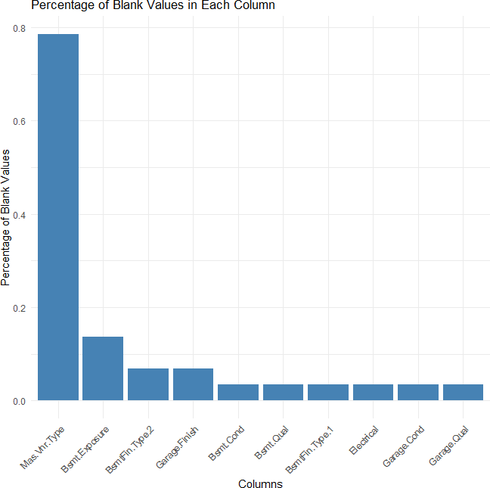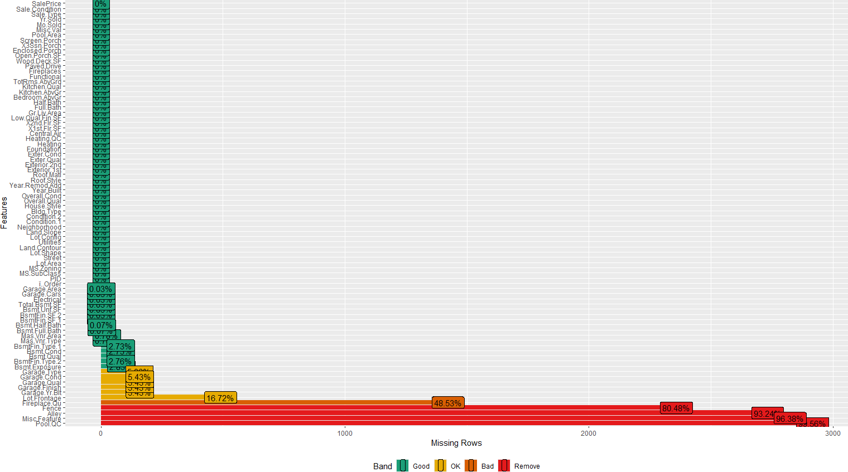

The dataset was examined for blank values, and the columns with the most missing values were identified using a bar chart. Then, for uniform data management, these blanks were changed to NA values.

## Data Cleaning:

We looked at how much of the Ames Housing dataset was missing. Columns with missing value percentages more than 40% were deemed possibly untrustworthy because of the significant amount of missing data. To facilitate more thorough analysis, these indicated columns were subsequently eliminated from the data frame.

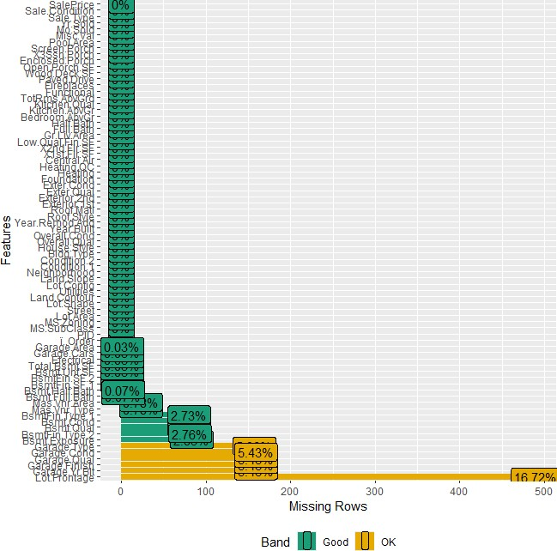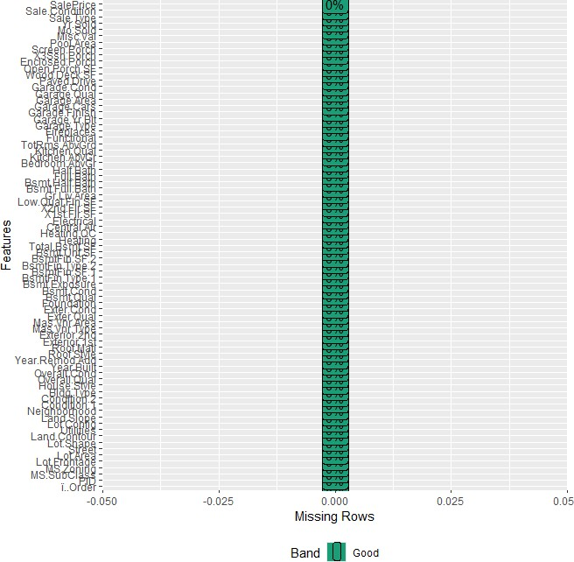

Lastly, a custom function called get_mode substituted the mode value of a column for missing values in categorical columns, and the median value of a column was used to replace all NA values in numerical columns.

## Boxplot of Sale price:

**Key Insights:** The data is favorably skewed, with a lengthy tail towards higher values, according to the sale price boxplot. This implies that some homes have substantially greater sale values than the rest.

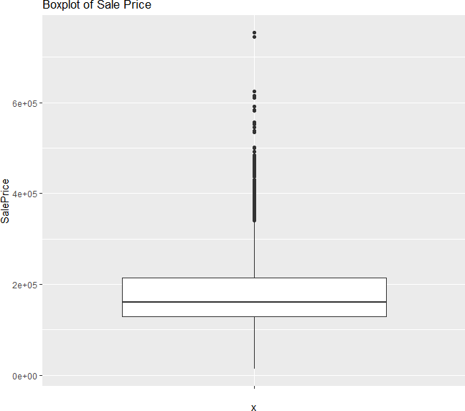

**Median**: The median sale price is approximately $200,000.

**Quartiles:** The first quartile (Q1) is around

$150,000, and the third quartile (Q3) is around

$250,000.

**Interquartile Range (IQR):** The IQR, the difference between Q3 and Q1, is about

$100,000.

**Outliers:** There are several outliers above the upper whisker, indicating houses with exceptionally high sale prices.

## Data Visualization with respect to the Sale Price:

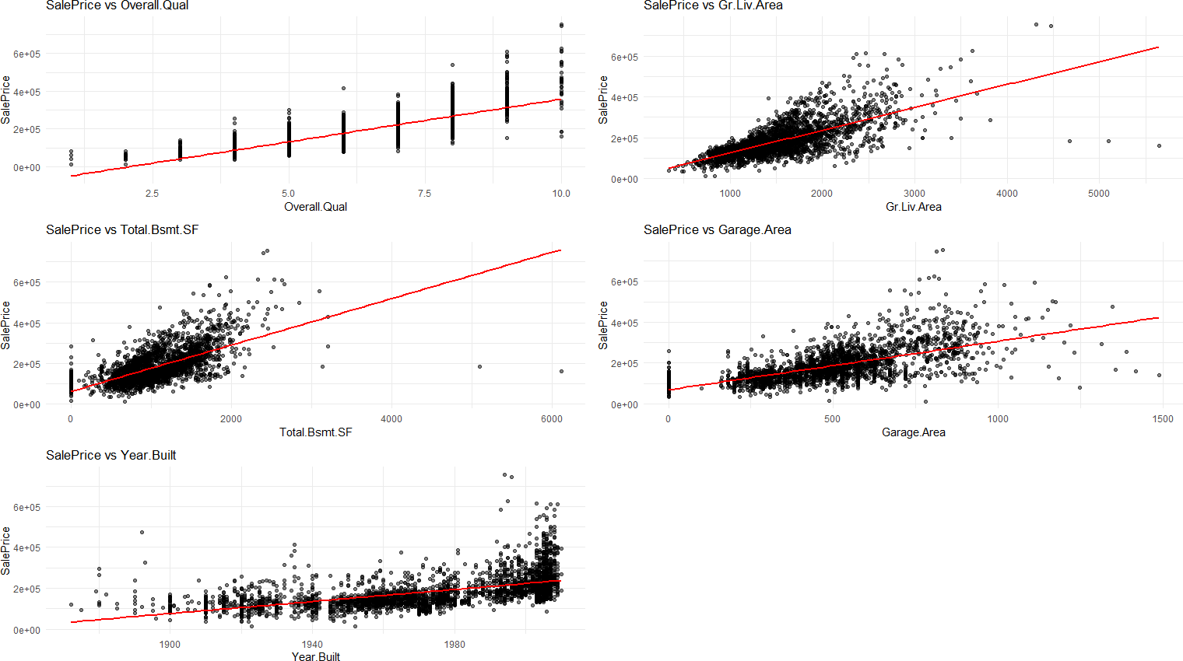

* **Sale Price vs Overall Quality (Overall Quality):** There's a strong positive relationship, indicating that houses with higher overall quality ratings tend to have higher sale prices
* **Sale Price vs Above Ground Living Area (Gr Liv Area):** There's a clear positive relationship, suggesting that larger houses generally sell for higher prices.
* **Sale Price vs Total Basement Square Feet (Total.Bsmt.SF):** There's a positive relationship, but it's not as strong as with the above-ground living area. Houses with larger basements tend to have higher sale prices, but there's more variability.
* **Sale Price vs Garage Area (Garage.Area):** There's a positive relationship, indicating that houses with larger garages tend to have higher sale prices, but the relationship isn't as strong as with overall quality or living area.
* **Sale Price vs Year Built (Year.Built):** There's a slight positive trend, suggesting that newer houses tend to sell for somewhat higher prices, but the relationship isn't as strong as with the other variables.

## Correlation Analysis Using HeatMap:

The graphic shows a symmetric matrix with the correlation between two variables represented in each cell. Dark red denotes a strong positive connection, white denotes no association, and dark blue denotes a strong negative correlation. The hierarchical organization of the variables groups together those that exhibit comparable correlation patterns.

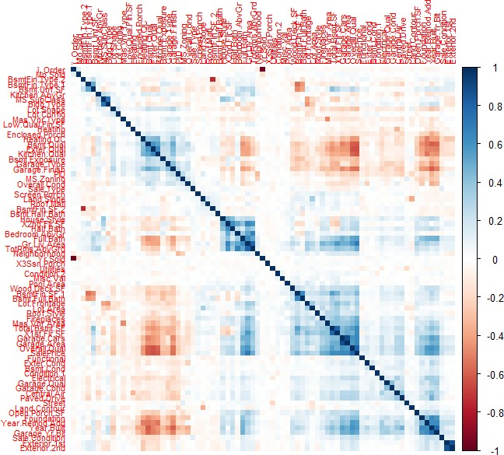

**Strong Positive Correlations:** The variables most strongly correlated with **'SalePrice'** include **'Overall Qual'**, **'Gr Liv Area'**, **'Total Bsmt SF'**, **'Garage Area'**, and **'1st Flr SF'**. This indicates that factors such as the quality of the house, its total living area, and the sizes of specific areas (basement, garage, and first floor) are key predictors of sale price.

## Scatterplots of Total Basement Area Vs variable with Highest / Lowest /

**0.5 correlations with SalePrice:**

### Total Basement Area Vs Variable with Highest Correlation to Sale Price:

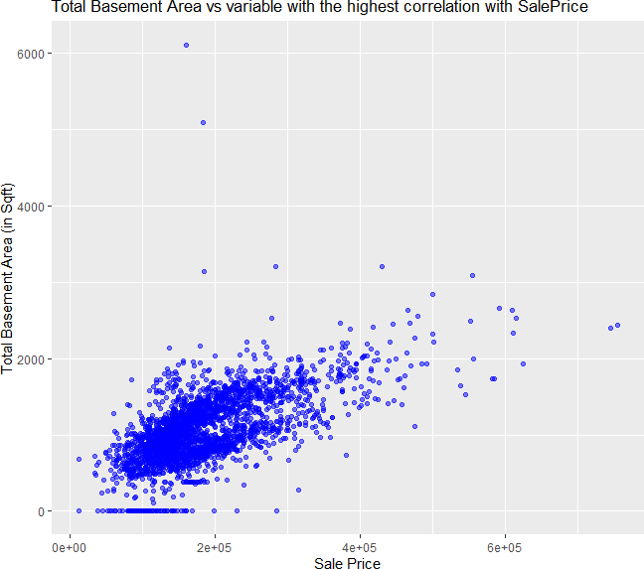

Variable with Highest Correlation with SalePrice – SalePrice

Total Basement Area and SalePrice, the variable most strongly connected with it, have a significant positive association, according to this scatter plot. Total Basement Area tends to rise in tandem with selling Price, indicating that residences with larger basements are often of greater quality or provide more living space, both of which raise selling prices.

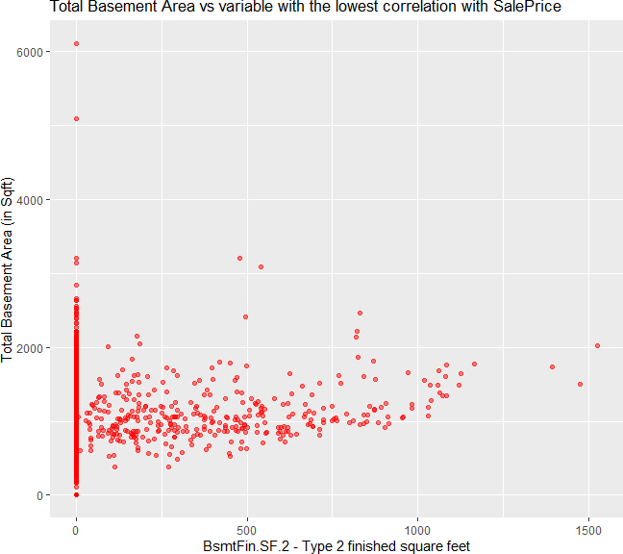

### Total Basement Area Vs Variable with Lowest Correlation to Sale Price:

Variable with Lowest Correlation with SalePrice – BsmtFin.SF.2

According to this scatter plot, there is a considerable positive correlation between Total Basement Area and SalePrice, the variable that is most closely related to it. The fact that the total basement area tends to increase in proportion to the selling price suggests that homes with larger basements are often of higher quality or offer more living space, both of which drive up selling prices.

### Total Basement Area Vs Variable with 0.5 Correlation to Sale Price:

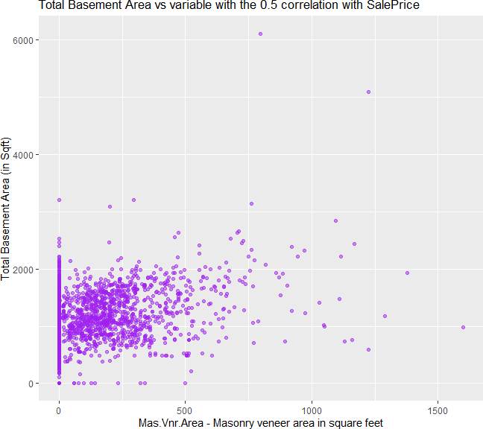

Variable with 0.5 Correlation with **SalePrice** – **Mas.Vnr.Area**

A variable having a mid-level correlation to SalePrice (around 0.5) and Total Basement Area have a somewhat favorable association, according to this scatter plot. Even while the tendency is not as strong as it was in the previous plot, it is still noticeable. For example, greater basements may be found in homes with more recent construction dates or larger garage areas, which somewhat raises sale prices.

Regression Model:

#### Model 1:

**Outcome Variable**: Sale Price

**Predictor Variables**: Overall.Qual, Gr.Liv.Area, Year.Built, Total.Bsmt.SF, Garage.Area

**Equation of the model:**

SalePrice = β₀ + β₁(Overall.Qual) + β₂(Gr.Liv.Area) + β₃(Year.Built) + β₄(Total.Bsmt.SF) + β₅(Garage.Area) + ε

Where,

Intercept (β₀): -7.361e+05

Overall.Qual coefficients (β₁): 2.109e+04 Gr.Liv.Area coefficients (β₂): 5.145e+01 Year.Built coefficients (β₃): 3.328e+02 Total.Bsmt.SF coefficients (β₄): 3.067e+01 Garage.Area coefficients (β₅): 4.834e+01

|  |  |  |  |
| --- | --- | --- | --- |
| R2 | Adjusted R2 | Residual Std. Error | F Statistic |
| **0.7884** | **0.788** | **36780**  **(DF = 2924)** | **2178 on 5 and 2924 DF** |

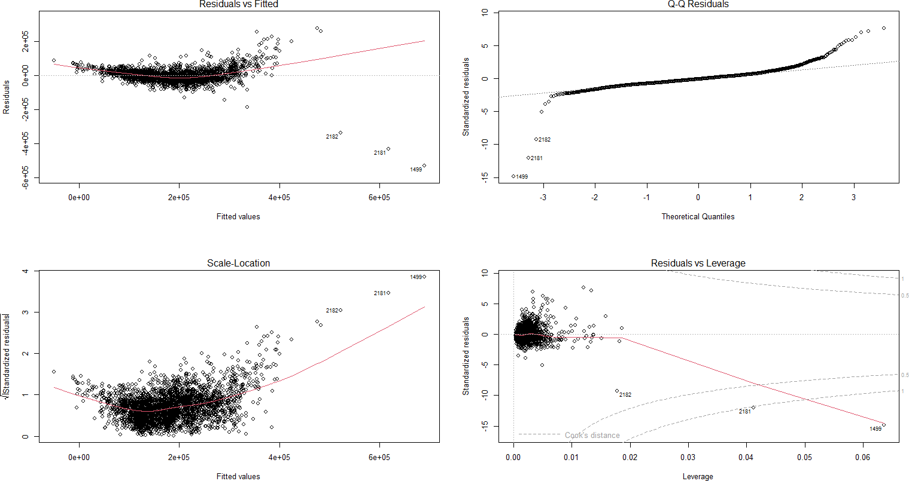

#### Residuals vs Fitted (Top Left):

* + **Interpretation**: On the x-axis, the fitted values (predicted SalePrice) are shown against the residuals (errors) on the y-axis.
  + **Insight**: Ideally, residuals should appear randomly scattered around zero without any discernible pattern. In this plot, however, a slight curve is visible, hinting at some non-linearity in the model. This suggests that the model may not fully capture the relationship between the predictors and SalePrice, indicating possible issues with model fit.

#### Normal Q-Q Plot (Top Right):

* + **Interpretation**: This plot checks if the residuals follow a normal distribution. The points should ideally fall along the 45-degree line.
  + **Insight**: Residuals should ideally be randomly distributed around zero, showing no specific pattern. However, in this plot, a slight curve suggests the presence of non-linearity in the model. This indicates that the model might not be fully capturing the relationship between the predictors and SalePrice, pointing to potential issues with model fit.

#### Scale-Location Plot (Bottom Left):

* + **Interpretation**: The square root of the standardized residuals is plotted against the fitted values in order to determine if the residuals are homoscedastic (constant variance).
  + **Insight**: The red line shows an upward trend, indicating heteroscedasticity (uneven variance). As fitted values increase, the spread of residuals widens, suggesting that error variability grows with higher SalePrice predictions. This pattern violates a core assumption of linear regression, which assumes constant variance of errors across all levels of the predicted values.

#### Residuals vs Leverage Plot (Bottom Right):

* + **Interpretation**: This plot helps identify influential data points. Points with high leverage or high standardized residuals can have a large impact on the regression model.
  + **Insight**: Certain points, including observations 2182 and 1499, exhibit high leverage and appear to be influential outliers. These points fall outside Cook's distance lines, suggesting they may disproportionately impact the model’s predictions. Further investigation of these points is advisable to determine whether they should be removed or adjusted.

## Calculating MRSE, AIC, BIC:

**Mean Residual Standard Error (MRSE):** Mean Residual Standard Error (MRSE) is essential for assessing a model's accuracy and reliability. A lower MRSE indicates a better fit, as it means the model's predictions are closer to the actual values, enhancing the model's precision.  
The MRSE value of the model is **679.5209**

**AIC (Akaike Information Criterion):** The criterion penalizes models with additional parameters, though less harshly than the Bayesian Information Criterion (BIC). Its goal is to strike a balance between model fit and complexity, making it particularly useful when aiming to find a model that performs well in predicting future observations.

The AIC value of the model is **69927.79**

**BIC (Bayesian Information Criterion):** This criterion penalizes models with additional parameters more strongly than the Akaike Information Criterion (AIC), generally favoring simpler models, even if they don’t fit the data as closely as more complex ones. It’s often used when the aim is to identify the "true" model that most accurately represents the data generation process.

The BIC value of the model is **69969.67**

## Checking for multicollinearity in the Model:

A measure of how much multicollinearity inflates a regression coefficient's variance is called the Variance Inflation Factor (VIF). The variable is significantly linked with other variables in the model if its VIF is high.

|  |  |  |  |  |
| --- | --- | --- | --- | --- |
| Overall.Qual | Gr.Liv.Area | Year.Built | Total.Bsmt.SF | Garage.Area |
| 2.440698 | 1.691470 | 1.726083 | 1.574292 | 1.732841 |

Values of the predictors < 10: Not concerning

Values of the predictors > 10: high level of multicollinearity

Since **all the values of the predictors are lying between 1 and 2** hence we can say there is **No multicollinearity in our Model.**

## Checking for Outliers in the Model:

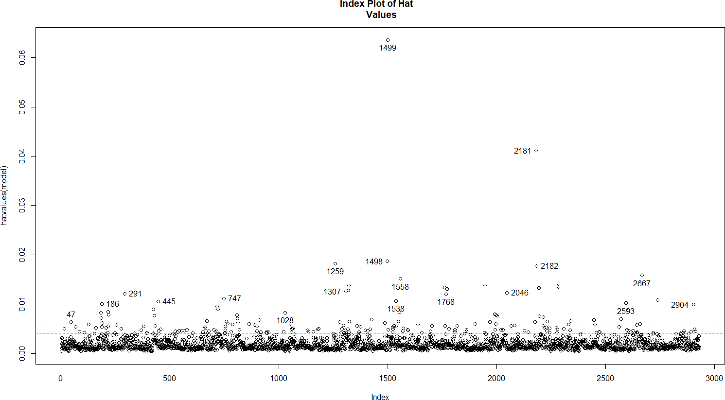

**Hat Values:** Each observation's leverage on the model is indicated by the hat values on the y-axis of this graphic. The fit of the model is more significantly impacted by observations with higher hat values. The index of observations in the dataset is shown on the x-axis.

**High-Leverage Points:** Several observations fall above the red dashed lines, marking them as high-leverage points. Key high-leverage observations include 1499, 2181, 2182, 1768, and 1761, among others. These points exert considerable influence on the regression model and warrant further investigation to assess their impact.

## Potential Influence on Model: High-leverage points can heavily impact the regression coefficients, which may result in a biased or unstable model. It’s important to examine these observations closely to determine if they are valid data points or if they represent outliers or errors that might need to be removed or handled differently.

## After Removing Outliers from the Model:

#### Model 2:

**Outcome Variable**: Sale Price

**Predictor Variables**: Overall.Qual, Gr.Liv.Area, Year.Built, Total.Bsmt.SF, Garage.Area

**Equation of the model:**

SalePrice = β₀ + β₁(Overall.Qual) + β₂(Gr.Liv.Area) + β₃(Year.Built) + β₄(Total.Bsmt.SF) + β₅(Garage.Area) + ε

Where,

Intercept (β₀): -6.660e+05

Overall.Qual coefficients (β₁): 1.633e+04 Gr.Liv.Area coefficients (β₂): 5.525e+01 Year.Built coefficients (β₃): 3.064e+02 Total.Bsmt.SF coefficients (β₄): 3.485e+01 Garage.Area coefficients (β₅): 4.633e+01

|  |  |  |  |
| --- | --- | --- | --- |
| R2 | Adjusted R2 | Residual Std. Error | F Statistic |
| **0.8604** | **0.8602** | **23900 (DF = 2633)** | **3246 on 5 and 2633 DF** |

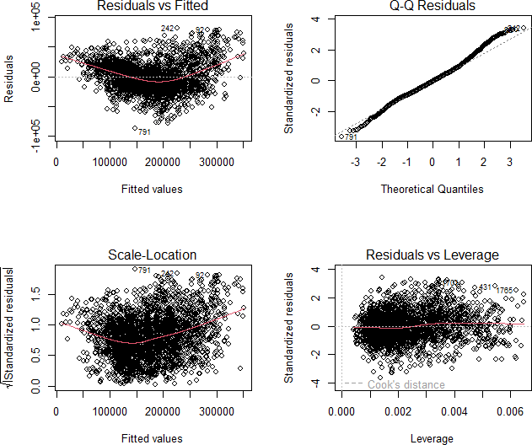

## Does Removing Outliers Improve the Model?

Yes, after removing the outliers it improved the model.

#### Lower Residual Standard Error (MRSE):

Model 2 shows a notably lower Mean Residual Standard Error (MRSE) of 441.499 compared to Model 1’s 679.5209. This suggests that Model 2’s predictions are, on average, closer to the actual values, providing a better fit to the data.

#### Higher Adjusted R-squared:

#### Model 1's adjusted R-squared is 0.788, whereas Model 2's is 0.8602. After controlling for the number of predictors, this indicates that Model 2 accounts for a higher percentage of the variance in the dependent variable.

#### Lower AIC and BIC:

Model 2 has lower AIC and BIC values. These information criteria penalize models with more parameters. Lower values indicate a better balance between model fit and complexity.

## Subsets regression method to identify the "best" model:

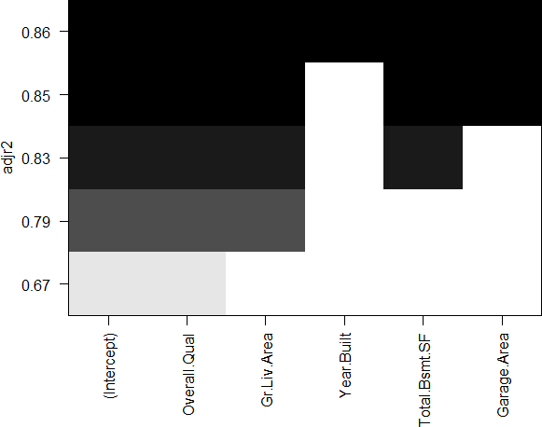

The regression model's adjusted R-squared values for different subsets of variables are shown in the plot. The model's fit to the data after accounting for the number of predictors is shown by adjusted R-squared. A model that better fits the data, balancing predictive power and model complexity, is indicated by a higher adjusted R-squared.

**Best Model:** The model achieving the highest adjusted R-squared includes all variables except "Year.Built." Among the subsets evaluated, this model offers the best fit to the data.

#### Variable Importance:

- "**Overall.Qual**" and "**Gr.Liv.Area**" appear to be the most influential variables, contributing substantially to the adjusted R-squared even in simpler models.

- "**Total.Bsmt.SF**" and "**Garage.Area**" also positively affect the model’s fit, though their impact is somewhat less pronounced compared to the top two variables.

## Comparison between Model 2 and Subsets regression Model:

Both Model 2 and the subset regression model demonstrate strong predictive performance, with each achieving an adjusted R-squared of 0.86. This similarity suggests that the extra variables included in the subset regression model may not add significant incremental value to the prediction accuracy.

## Report Summary:

In this analysis, we built a linear regression model to predict house prices based on five continuous variables: Overall Quality, Above Ground Living Area, Year Built, Total Basement Area, and Garage Area. Diagnostic plots were used to evaluate the model's performance, identifying potential issues with high-leverage points (such as observations 1499, 2181, and 2182), as well as signs of non-linearity and heteroscedasticity. Scatter plots between SalePrice and the predictors showed strong positive correlations, particularly for Overall Quality and Living Area. To refine the model, we examined and removed outliers and influential points, as they could potentially distort model accuracy.

## References:

GeeksforGeeks. (n.d.). *Detecting multicollinearity with VIF in Python*. Retrieved from <https://www.geeksforgeeks.org/detecting-multicollinearity-with-vif-python/>

Statistics By Jim. (n.d.). *Multicollinearity in regression analysis: Problems, detection, and solutions*. Retrieved from <https://statisticsbyjim.com/regression/multicollinearity-in-regression-analysis/>

## Appendix:

# ================================================================================

# Loading Necessary Libraries

# ================================================================================

library(readr)

library(dplyr)

library(tidyr)

library(ggplot2)

library(scales)

library(corrplot)

library(DataExplorer)

library(gridExtra)

library(car)

library(leaps)

# ================================================================================

# Step 1: Reading the Dataset

# ================================================================================

# Load the Ames housing dataset

ames_data <- read.csv("C:/Users/ayush/Downloads/Intermediate_Analytics/AmesHousing.csv")

head(ames_data)

# ================================================================================

# Step 2: Exploratory Data Analysis

# ================================================================================

# Display column names

column_names <- names(ames_data)

print(column_names)

# Get the structure and summary of the dataset

str(ames_data)

summary(ames_data)

# ================================================================================

# Step 3: Displaying Columns with Blank ("") Values in Plot

# ================================================================================

# Calculate the percentage of blank ("") values in each column

blank_percentage <- sapply(ames_data, function(x) sum(x == "", na.rm = TRUE)) / nrow(ames_data) * 100

blank_df <- data.frame(Column = names(blank_percentage), Blank_Percentage = blank_percentage)

blank_df <- subset(blank_df, Blank_Percentage > 0)

# Plot the percentage of blank values for each column

ggplot(blank_df, aes(x = reorder(Column, -Blank_Percentage), y = Blank_Percentage)) +

geom_bar(stat = "identity", fill = "steelblue") +

theme_minimal() +

labs(title = "Percentage of Blank Values in Each Column",

x = "Columns",

y = "Percentage of Blank Values") +

theme(axis.text.x = element_text(angle = 45, hjust = 1))

# Convert blank ("") values to NA in the entire dataframe

ames_data[ames_data == ""] <- NA

# Checking for NA values in each column

colSums(is.na(ames_data))

# View missing data patterns

plot_missing(ames_data)

# ================================================================================

# Step 4: Removing Columns that Have Missing Values > 40%

# ================================================================================

# Calculate the percentage of missing values for each column

missing_percent <- sapply(ames_data, function(x) sum(is.na(x)) / length(x) * 100)

# Print the names of columns that were dropped

dropping_columns <- names(missing_percent[missing_percent > 40])

print("Dropping columns:")

print(dropping_columns)

# Filter out columns where the missing percentage is greater than 40%

ames_data <- ames_data[, missing_percent <= 40]

# View missing data patterns

plot_missing(ames_data)

# ================================================================================

# Step 5: Handling Missing Values (Categorical - Mode, Numerical - Median)

# ================================================================================

# Function to calculate mode

get_mode <- function(x) {

unique_values <- unique(x)

unique_values[which.max(tabulate(match(x, unique_values)))]

}

# Handling missing values in ames_data

ames_data <- ames_data %>%

# Replace NA in numeric columns with median

mutate(across(where(is.numeric), ~ ifelse(is.na(.), median(., na.rm = TRUE), .))) %>%

# Convert character columns to factor to ensure compatibility with get_mode

mutate(across(where(is.character), as.factor)) %>%

# Replace NA in factor (categorical) columns with mode

mutate(across(where(is.factor), ~ ifelse(is.na(.), get_mode(na.omit(.)), .)))

# View missing data patterns

plot_missing(ames_data)

# ================================================================================

# Step 6: Visualizations

# ================================================================================

# Visualizations

# View histograms of variables

hist(ames_data$SalePrice, main = 'Sale Price')

# View boxplots of variables

ggplot(ames_data, aes(x = "", y = SalePrice)) +

geom_boxplot() +

labs(title = "Boxplot of Sale Price")

# Select variables to plot against SalePrice

variables <- c("Overall.Qual", "Gr.Liv.Area", "Total.Bsmt.SF", "Garage.Area", "Year.Built")

# Create a list to store individual plots

plots <- list()

# Create scatter plots for each variable

for (var in variables) {

p <- ggplot(ames_data, aes_string(x = var, y = "SalePrice")) +

geom_point(alpha = 0.5) +

geom_smooth(method = "lm", se = FALSE, color = "red") +

labs(title = paste("SalePrice vs", var),

x = var,

y = "SalePrice") +

theme_minimal()

plots[[var]] <- p

}

# Arrange plots in a grid

library(gridExtra)

grid.arrange(grobs = plots, ncol = 2)

# ================================================================================

# Step 7: Correlation Analysis

# ================================================================================

# Producing a correlation matrix for numeric values

numeric_ames_data <- ames_data[, sapply(ames_data, is.numeric)]

cor_matrix <- cor(numeric_ames_data, use = "complete.obs")

# Plotting the correlation matrix

corrplot(cor_matrix, method = "color", order = "hclust", tl.cex = 0.7)

# ================================================================================

# Step 8: Making Scatter Plots for Total Basement Area vs Sale Price

# ================================================================================

# Find highest correlation with SalePrice

highest_cor <- names(which.max(abs(cor_matrix["SalePrice", ])))

print(highest_cor)

ggplot(ames_data, aes_string(x = highest_cor, y = "Total.Bsmt.SF")) +

geom_point(color = 'blue', alpha = 0.5) +

labs(title = "Total Basement Area vs variable with the highest correlation with SalePrice",

x = "Sale Price",

y = "Total Basement Area (in Sqft)")

# Find lowest correlation with SalePrice

lowest_cor <- names(which.min(abs(cor_matrix["SalePrice", ])))

print(lowest_cor)

ggplot(ames_data, aes_string(x = lowest_cor, y = "Total.Bsmt.SF")) +

geom_point(color = 'red', alpha = 0.5) +

labs(title = "Total Basement Area vs variable with the lowest correlation with SalePrice",

x = "BsmtFin.SF.2 - Type 2 finished square feet",

y = "Total Basement Area (in Sqft)")

# Find correlation closest to 0.5 with SalePrice

mid_cor <- names(which.min(abs(abs(cor_matrix["SalePrice", ]) - 0.5)))

print(mid_cor)

ggplot(ames_data, aes_string(x = mid_cor, y = "Total.Bsmt.SF")) +

geom_point(color = 'purple', alpha = 0.5) +

labs(title = "Total Basement Area vs variable with the 0.5 correlation with SalePrice",

x = "Mas.Vnr.Area - Masonry veneer area in square feet",

y = "Total Basement Area (in Sqft)")

# ================================================================================

# Step 9: Fitting a Regression Model

# ================================================================================

# Fitting a regression model using 5 continuous variables

model1 <- lm(SalePrice ~ Overall.Qual + Gr.Liv.Area + Year.Built + Total.Bsmt.SF + Garage.Area, data = ames_data)

summary(model1)

# Plotting the regression model

par(mfrow = c(2, 2))

plot(model1)

# Calculating the Mean Residual Standard Error (MRSE) for the model

rse <- summary(model1)$sigma

n1 <- nrow(ames_data)

mrse <- rse / sqrt(n1)

mrse

# Calculating AIC and BIC of the model:

AIC(model1)

BIC(model1)

# ================================================================================

# Step 10: Checking for Multicollinearity and Outliers

# ================================================================================

# Checking for multicollinearity

library(car)

vif(model1)

# Checking for outliers using Bonferroni test

outliers <- outlierTest(model1)

print(outliers)

# Plotting high-leverage observations

hat.plot <- function(model1) {

p <- length(coefficients(model1))

n <- length(fitted(model1))

plot(hatvalues(model1), main = "Index Plot of Hat Values")

abline(h = c(2, 3) * p / n, col = "red", lty = 2)

identify(1:n, hatvalues(model1), names(hatvalues(model1)))

}

hat.plot(model1)

# Influential observations

cutoff <- 4 / (nrow(ames_data) - length(model1$coefficients) - 2)

plot(model1, which = 4, cook.levels = cutoff)

abline(h = cutoff, lty = 2, col = "red")

# ================================================================================

# Step 11: Using All Subsets Regression to Identify the "Best" Model

# ================================================================================

# Using all subsets regression to identify the "best" model

subsets <- regsubsets(SalePrice ~ Overall.Qual + Gr.Liv.Area + Year.Built + Total.Bsmt.SF + Garage.Area,

data = ames_data, nvmax = 5)

summary(subsets)

# Plotting subsets regression:

plot(subsets, scale = "adjr2")